**Part-A**

**Explaination:**

**Code-1:**

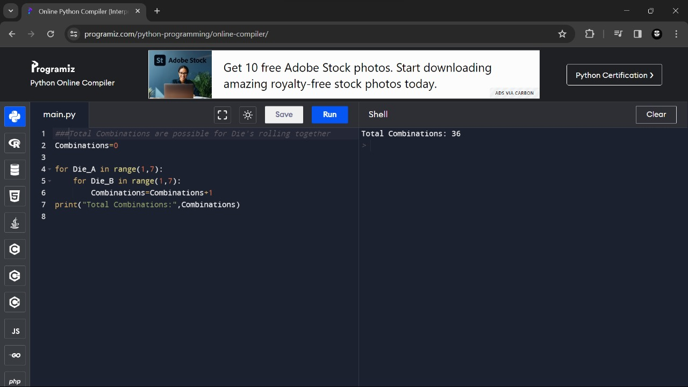

**In this Code:**

* The Outer Loop (For Die_A in range (1,7)) represents the faces of Die_A, ranging from 1 to 6.
* The Inner Loop (For Die_B in range (1,7)) represents the faces of Die_B, ranging from 1 to 6.
* For Each Combination of faces on Die_A and Die_B, the variable “Combinations” is incremented.
* The final result is the total number of combinations calculated by the nested loops.

**Output:**



**Code-2:**

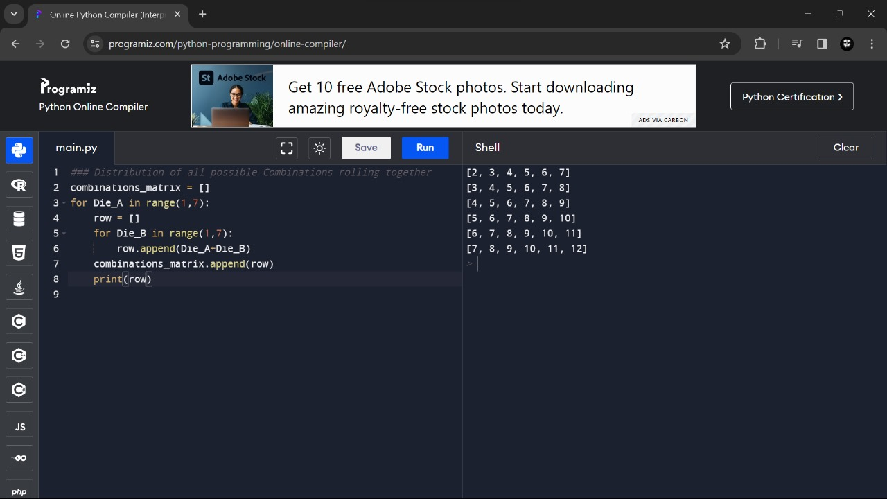

**In this Code:**

* The Outer Loop (For Die_A in range (1,7)) iterates through the faces of Die_A, ranging from 1 to 6.
* The Inner Loop (For Die_B in range (1,7)) iterates through the faces of Die_B, ranging from 1 to 6.
* For Each Combination of faces on Die A and Die B, the sum is calculated (“Die_A+Die_B”) and added to the row.
* The Row, representing a set of combinations for a specific face on Die A, is then added to the “Combinations_Matrix”.
* The Optional “Print(row)” statement displays each row, providing insight into the composition of the matrix.

**Output:**



**Code-3:**

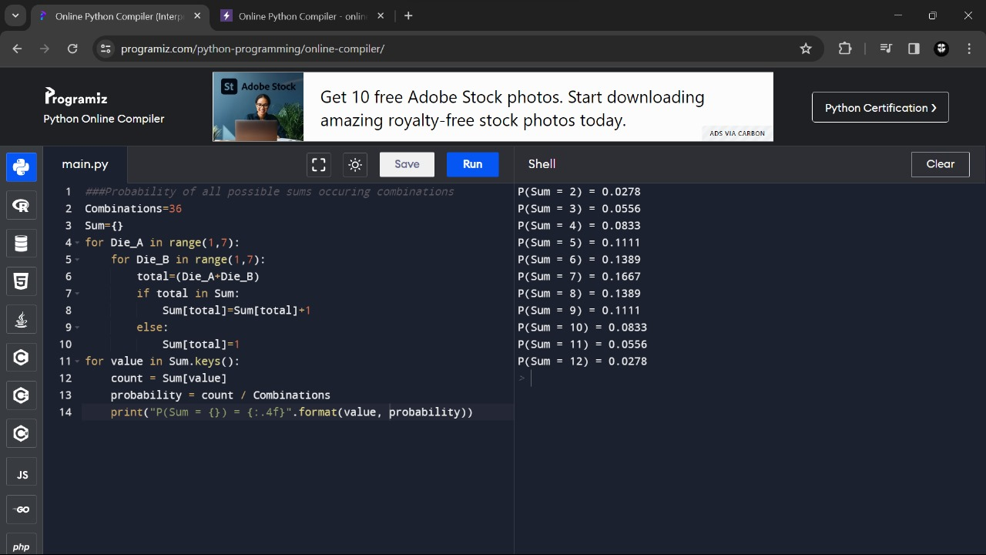

**In this Code:**

* The Variable “Combinations” is Initialized to 36, representing the total number of combinations when rolling two six-sided dice.
* The “Sum” it is dictionary is used to store the count of Occurrences for each possible sum.
* The nested loops iterate through all combinations of faces on Die A and Die B, Calculating the sum for each combination.
* The Dictionary is updated to keep track of the count of Occurrences for each sum.
* Finally, the script calculates and displays the probability for each sum by dividing the count by the total number of combinations.

**Output:**

